Salute to 'Safe Room' supporters
Published 4:00pm 10 January 2024
Words by Nick Crockford
Pictured: Officers from Deception Bay, Redcliffe and Mango Hill/North Lakes with members of Zonta Redcliffe, Bunnings Rothwell and Burpengary Men's Shed.
A new ‘safe room’ has been officially opened at Deception Bay Police Station for victims of domestic violence (DV).
Similar rooms have also been set-up at Redcliffe and North Lakes/Mango Hill stations after a community appeal run by the Zonta Club of Redcliffe.
Using donated paint, equipment, furnishings and toys, the Zonta club volunteers have made a designated room at each station more welcoming.
Last July Senior Constable Keith Morris, of the Vulnerable Persons Unit in Deception Bay, asked Zonta to help create "safe" spaces for reporting traumatic crimes.At a ceremony in Deception Bay Police Station just six months later, Snr Con Morris paid tribute to the community groups, businesses and volunteers who have transformed three rooms.
He was joined by Acting Chief Superintendent Adam Guild; A/Inspector Michelle Dodds from the Patrol Group; A/Senior Sergeant Officer-in-Charge of Vulnerable Persons Group Zoe Rowling; A/Senior Sergeant Jake Lacy, Officer-in-Charge Redcliffe and A/Senior Sergeant Janine Feyaerts Officer-in-Charge Mango Hill/North Lakes.
Senior Sergeant Jason Higgs, Officer-in-Charge at Deception Bay, was unable to attend.
“Over the last few years there has been a lot of research and training related to domestic violence,” Snr Con Morris said, “we’ve learned much about the benefits of a trauma-informed approach.
“We also know there can be barriers to reporting domestic violence, such as caring for young children or general apprehension about attending a police station.
“Each of these rooms we have created has a relaxed and comfortable feel with casual seating, art on walls, toys, books and digital distractions.
“Thank you so much to Zonta and other contributing businesses.”
Certificates of appreciation were given to Redcliffe Zonta, Burpengary Men’s Shed, Bunnings Rothwell, Costco North Lakes, Peninsula Fair, the Church of Jesus Christ and Latter Day Saints and Furniture Court Redcliffe.
“We were thrilled to be involved,” Redcliffe Zonta President Jenny Osborne said, “we really like to do this work for people who need it.
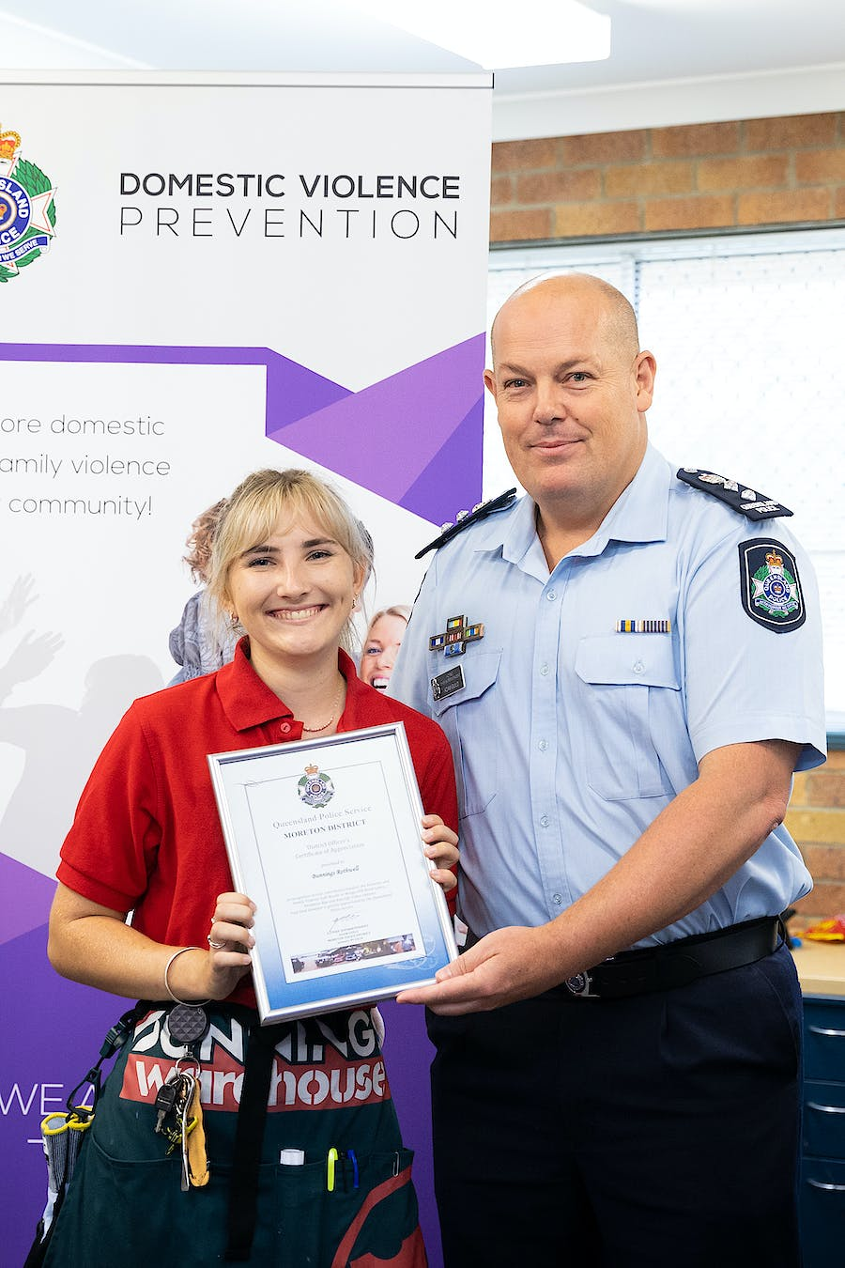Acting Chief Superintendent Adam Guild presenting a Certificate of Appreciation to Bunnings Rothwell.
“We felt it was our duty because that’s what we advocate for, a better world for women and girls … and any vulnerable people in our community.
“If we have gone one little step to helping them, then it was all worth it.
“To everyone who donated, it was wonderful. It was a community effort and excellent to get that support.”
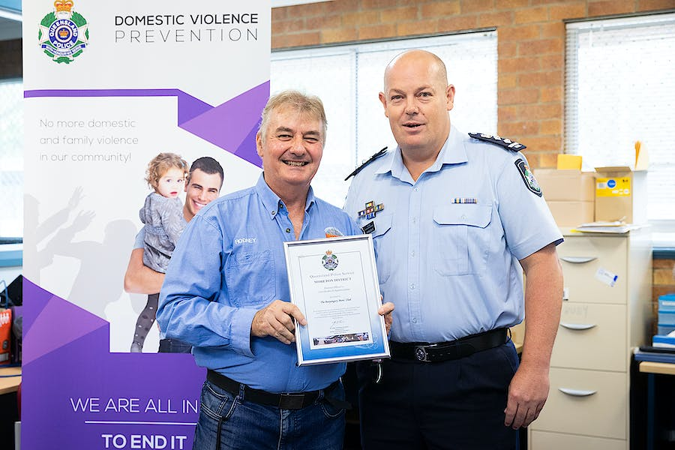Acting Chief Inspector Adam Guild presenting a Certificate of Appreciation to Burpengary Men's Shed
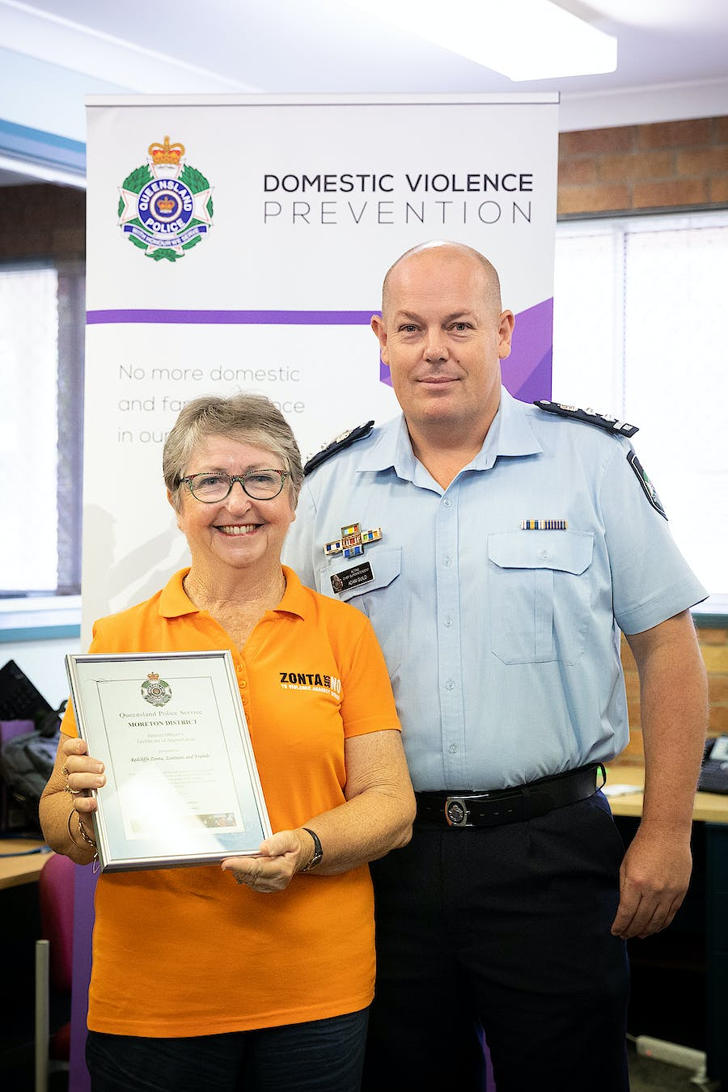Acting Chief Superintendent Adam Guild presenting a Certificate of Appreciation to the Zonta Club of Redcliffe

