Sheree Hoddinett
Local Times. Published 02/01/2024
Creating A Safe Space
Imagine a safe space for those experiencing domestic violence to share the details with police when they need to? Well, you no longer have to imagine it, as these spaces have become a reality at three of our local police stations and it’s all been made possible thanks to collaboration between the ladies from the Zonta Club of Redcliffe Inc. and the Vulnerable Persons Unit at Deception Bay. The establishment of the safe rooms at Deception Bay Police Station, North Lakes/Mango Hill Police Station and Redcliffe Police Station has all come together over the last few months with the procurement of the rooms, painting and fitting them out with furniture along with other bits and pieces.
When Zonta Club of Redcliffe Inc. president Jenny Osborne was first approached by Deception Bay acting sergeant Keith Morris with the idea of creating a safe room, she was keen to get on board.
“Keith is with the Vulnerable Persons Unit at Deception Bay and he was keen to get this idea off the ground,” Jenny says. “So he contacted me and our Zonta Club at Redcliffe was more than happy to take on the project for the three stations being Deception Bay, Redcliffe and Mango Hill/North Lakes.

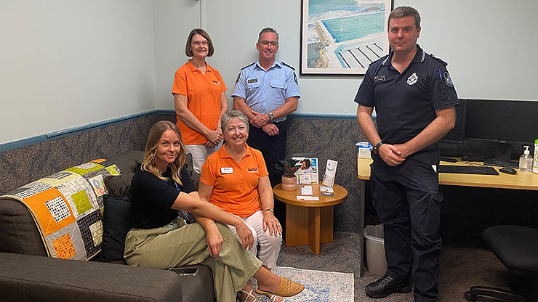
Lee Dawson from the Zonta Club of Redcliffe Inc., Acting Inspector Jason Higgs and Acting Sergeant Keith Morris from Deception Bay Police Station, Dee from the Centre Against Domestic Abuse and Zonta Club of Redcliffe Inc. president Jenny Osborne are happy to see the safe room at Deception Bay Police Station in its finished state.
“We have taken on the task of painting the rooms and decorating them with a sofa, bookcase, tables and chairs for the kids with a tablet, books, puzzles and colouring-in books and pencils, so the person who is reporting has something for their children to keep them entertained.”
Jenny put the feelers out to a number of local businesses to see who would be interested in supporting the project and the response was amazing. Bunnings Rothwell provided all the paint and painting equipment for the rooms, Costco at North Lakes donated towards the purchase of kids’ tables and chairs and the Church of Latter-Day Saints at Burpengary donated items including books, colouring-in books and pencils.
“The generosity out in the community has been overwhelming,” Jenny says. “Anyone who hears about it is more than happy to provide us with items. It has become a real community-focused project, which is so great for us.
“A lot of what we do at Zonta helps those experiencing domestic violence, which there is so much of out there at present, it’s so prevalent. We try so hard to do a lot of work to say no to domestic violence, but it’s still there.”
“It has been great to have larger businesses help us, but it’s the local businesses that have been a big help as well. We are extremely grateful to Ron from Furniture Court Redcliffe because he has donated two bookcases and two, two-seater sofas. Without this wonderful support, a project like this wouldn’t be able to happen.”
But the generous support from the community doesn’t end there.
“I was talking to the marketing manager at Peninsula Fair to organise our club gift-wrapping for Christmas as part of our fundraising efforts,” Jenny says. “I told her about the safe rooms and she mentioned cleaning out the store room to see what she could find that we could use and she came up with a number of paintings from a local artist that we could hang in the rooms.
“It’s funny how you meet different people and talk about projects and their offer of help progresses it even further, so we have been really lucky with people donating things to us. It just blows your mind that people are so generous when they hear what it's for.”
Jenny has been a part of Zonta for several years due to her sister getting her involved and also because she wanted to give something back to the community.
“For me, taking on projects like the safe rooms does your soul a world of good and to do something like this is rewarding as you are helping people who are facing difficult circumstances,” Jenny says. “A lot of what we do at Zonta helps those experiencing domestic violence, which there is so much of out there at present, it’s so prevalent. We try so hard to do a lot of work to say no to domestic violence, but it’s still there.”
The Zonta Club of Redcliffe Inc. has multiple events throughout the year to raise awareness for domestic violence including guest speakers and even a local football game where they are able to provide safety cards with helpful information.
“For a little club, we do a lot of work to get the word out there,” Jenny says. “Partnering with other community groups, we also provide bags of essentials for women who are in need at a difficult time of their lives.
“We just keep gnawing away to try and make a difference in our community here. Our motto for the current two years, 2022-24, from the international president is ‘Building a Better World for Women and Girls’, so that’s what we’re aiming to do, bit by bit.”
While the project has taken longer to finish than Jenny had originally planned, this being due to the coordination of the wonderful volunteers and flood of support received, she is so grateful that Zonta has been able to bring it to fruition.
“Our club voted unanimously to make this project happen,” Jenny says. “We are really proud to be involved and that Keith invited us to come on board. This collaboration between the Zonta Club of Redcliffe Inc. and the Queensland Vulnerable Person’s Unit in saying no to domestic violence can only assist people in our local community.
“These safe rooms will provide a safe, calming space that gives off a different feel to a normal police interview room and help those who are reporting to at least feel a bit more at ease. This is what we’re aiming for, a safe space where people will be able to report what’s occurring instead of feeling uncomfortable entering a police station environment.”
If you want to know more about the Zonta Club of Redcliffe Inc. and the work they do, please reach out to them via info@zontaredcliffe.org.au or 0422 932 337.ver Miss An to receive monthly reminders about advertisement booking deadlines, special offers
and industry specific features!

