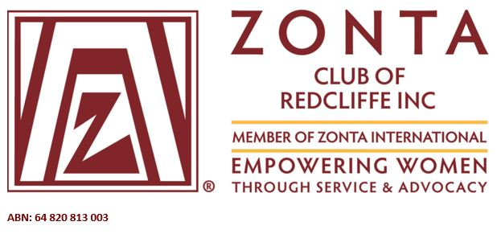
PO Box 131 | Margate | QLD | Australia |
www.zontaredcliffe.org.au | info@zontaredcliffe.org.au

Zonta Club of Redcliffe Inc
Young Women in Public Affairs Award Applications Available

The goal of the Young Women in Public Affairs (YWPA) Award Program is to encourage young women to participate in public affairs by recognising a young woman’s commitment to the volunteer sector, evidence of volunteer leadership achievements and a dedication to the empowerment of women.

Applicants are asked to reflect on their voluntary commitment to their school and to their community and the problems limiting the empowerment of women in their own country and worldwide. The Zonta International Young Women in Public Affairs Award Program looks to the young women of today to be the leaders of tomorrow.

This award is open to young women aged 16-19 on 1st April 2022 who reside, work or are studying at a secondary school, college, university, in the following areas:
Clontarf, Deception Bay, Margate, North Lakes, Redcliffe, Rothwell, Scarborough, Woody Point.

The application form along with further details for the 2022 Young Women in Public Affairs (YWPA) Award are now available on our website, or by clicking on the following link
Awards and Application Forms - ZONTA (zontaredcliffe.org.au)

The closing date for applications is Monday 28 February 2022. Applications must be received by Zonta Club of Redcliffe on or before this date to be considered. Applications can be submitted to The Secretary via email or post:
Email: info@zontaredcliffe.org.au
Post: PO Box 131
Margate QLD 4019

Zonta Club of Redcliffe Inc is part of Zonta International with its aim to empower women worldwide through service and advocacy. The Young Women in Public Affairs Award is one of many programs for women and girls sponsored by Zonta International. The Award is funded by voluntary contributions to the Zonta International Foundation Young Women in Public Affairs Award Fund.

We look forward to receiving your application. All applicants will receive a Certificate of Participation from our Club.

